Management 390 Industry Condition Analysis

Date: Mar. 1, 15

Ebook 66-93

Chapter 8 Business Strategy

* Two issues
  + What strategies are most effective at building sustainable competitive advantages for single business units
  + Should dominant-product/service businesses diversify to build value and competitive advantage

# Evaluating and choosing business strategies: seeking sustained competitive advantage

* Businesses become successful because they possess some advantage relative to their competitor
* Two most prominent sources of competitive advantage
  + Cost structure
  + Ability to differentiate the business
* Businesses that create the competitive advantages from one or both of these sources usually experience above-average profitability
* Generic strategies
  + Managers were advised to evaluate and choose strategies that emphasized one type of competitive advantage
* The studies indicate the highest profitability levels are found in
  + Businesses that have one or more resources/ capabilities that truly differentiate them from key competitors and also have resources/ capabilities that let them operate at a lower cost will consistently outperform their rivals that don’t.

## Evaluating cost leadership opportunities

* Requires
  + Able to provide its product or services at a cost below what its competitors can achieve
  + Must be a sustainable cost advantage by skills and resources
    - Skills
      * Sustained capital investment and access to capital
      * Process engineering skills
      * Intense supervision of labour or core technical operations
      * Products or services designed for ease of manufacture or delivery
      * Low-cost distribution system
    - Organizational requirement
      * Tight cost control
      * Frequent, detailed control reports
      * Continuous improvement and benchmarking orientation
      * Structured organization and responsibilities
      * Incentives based on meeting strict, usually quantitative targets
* Low-cost strategies
  + Business strategies that seek to establish long-term competitive advantages by emphasizing and perfecting value chain activities that can be achieved at costs substantially below what competitors are able to match on a sustained basis. This allows the firm, in turn, to compete primarily by charging a price lower than competitors can match and still stay in business
* Key basis
  + Low-cost advantages that reduce the likelihood of pricing pressure from buyers
  + Truly sustained low-cost advantages may push rivals into other areas, lessening price competition
  + New entrants competition on price must face an entrenched cost leader without experience to replicate every cost advantage
  + Low-cost advantages should lessen the attractiveness of substitute products
  + Higher margins allow low-cost producers to withstand supplier cost increases and often gain supplier loyalty over time
  + Many cost-saving activities are easily duplicated
  + Exclusive cost leadership can become a trap
  + Obsessive cost cutting can shrink other competitive advantages involving key product attributes
  + Cost differences often decline over time
    - Cost advantages that are not sustainable over a period of time are risky

## Evaluating differentiation opportunities

* Differentiation
  + A business strategy that seeks to build competitive advantage with its product or service by having it be “different” from other available competitive products based on features, performance, or other factors not directly related to cost and price. The difference would be one that would be hard to create and/ or difficult to copy or imitate
* Usually arise from one or more activities in the value chain that create a unique value important to the buyers
* The sustainability will be dependent on
  + A continuation of its high perceived value to buyers
  + A lack of limitation by competitors
* Value chain
  + Skills and resources
    - Strong marketing ability
    - Product engineering
    - Creative talent and flair
    - Strong capabilities in basic research
    - Corporate reputation for quality or technical leadership
    - Long tradition in an industry or unique combination of skills drawn from other businesses
    - Strong cooperation from channels
    - Strong cooperation from suppliers of major components of product or service
  + Organizational requirements
    - Strong coordination among function in R&D, product development, and marketing
    - Subjective measurement and incentives instead of quantitative measures
    - Amenities to attract highly skilled labour, scientists, and creative people
    - Tradition of closeness to key customers
    - Some personnel skilled in sales and operations – technical and marketing
* Key basis
  + Rivalry is reduced when a business successfully differentiate itself
  + Buyers are less sensitive to prices for effectively differentiated products
  + Brand loyalty is hard for new entrants to overcome
  + Imitation narrows perceived differentiation, rendering differentiation meaningless
  + Technological changes that nullify past investments or learning
  + The cost difference between low-cost competitors and the differentiated business becomes too great for differentiation to hold brand loyalty

## Evaluating speed as a competitive advantage

* Speed-based strategies
  + Business strategies built around functional capabilities and activities that allow the company to meet customer needs directly or indirectly more rapidly than its main competitors
* Speed is a form of differentiation
  + The availability of a rapid response to a customer by providing current products or quicker
  + Accelerating new-product development or improvement
  + Quickly adjusting product processes
  + Making decisions quickly
* Value chain
  + 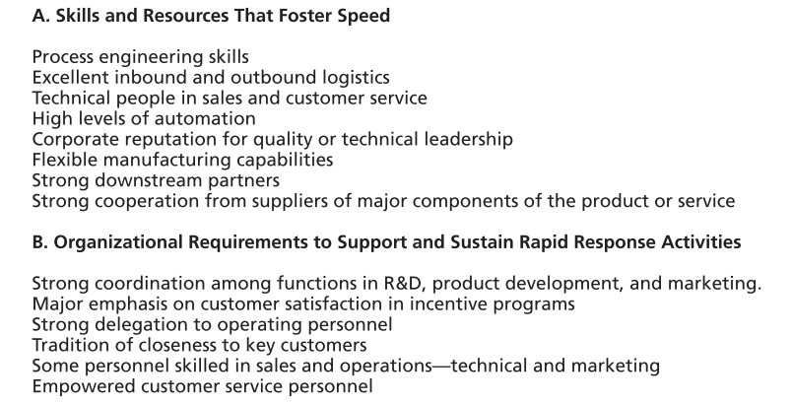
* Can be created through
  + Customer responsiveness
  + Product development cycle
  + Product or service improvement
  + Speed in delivery or distribution
  + Information sharing and technology
* Rapid response capabilities create competitive advantages in several ways
  + Lessen rivalry because they have availability of something that a rival may not have
    - Allow business to charge buyer more
    - Engender loyalty
    - Enhance the business’s position relative to the buyers
  + Substitute and new entrants find themselves trying to keep up with the rapid changes rather than introducing them
* Risks
  + Speeding up activities that haven’t been conducted in a fashion that prioritizes rapid response should only be done after considerable attention to training, reorganization, and/or reengineering
  + Some industries, stable mature have very minimal levels of change
    - This may not offer much advantage to the firm that introduces some forms of rapid response

## Evaluating market focus as a way to competitive advantage

* Market focus
  + This is a generic strategy that applies a differentiation strategy approach, or a low-cost strategy approach, or a combination – and does so solely in a narrow market niche rather than trying to do so across the broader market. The marrow focus may be geographically defined or defined by product type features, or target customer type, or some combination of these.
* Small companies usually thrive because of focusing on the narrow market niches
* Important for focus market
  + Business focussed on a narrow niche market in which to build a strong competitive advantage
  + Focus along was not enough to build competitive advantage
* Market focus allows some business to compete on the basis of low cost, differentiation, and rapid response against much larger businesses with greater resources
* Focus lets a business “learn” its target customer
  + Needs
  + Special considerations
  + Establish personal relationships in ways that differentiate the smaller firm or make it more valuable to target customer
* Cost advantage often centres around the high level of customized service the focus, smaller business can provide
* Focused business build up organizational knowledge about time-sensitive ways to work with customers
* Risk
  + Attract major competitor who have waited for your business to “prove” the market
  + Slipping into the illusion that it is focus itself, and not some special form of low cost, differentiation, or rapid response, that is creating the business’s success
* 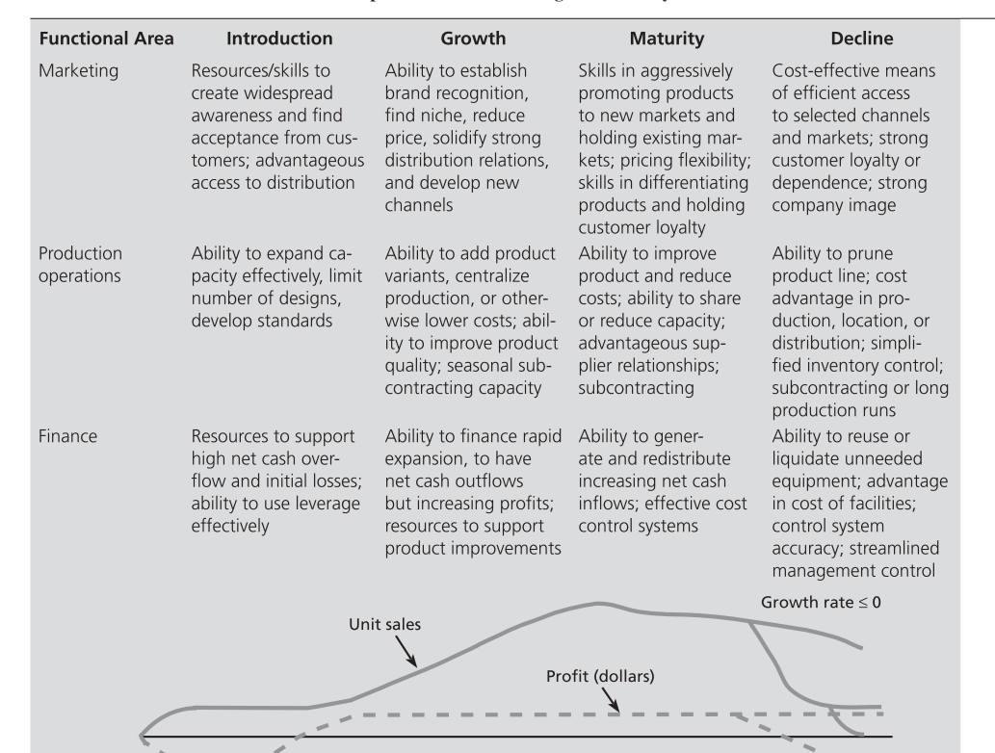
* Managers evaluating opportunities to build competitive advantage should link strategies to resources, capabilities, and value chain activities that exploit low cost, differentiation, and rapid response competitive advantages
* Advantageous
  + Consider ways to use focus to leverage these advantages
  + Enhance their likelihood of identifying these opportunities is to consider several different generic industry environments for the perspective of the typical value chain activities most often linked to sustained competitive advantages in those unique situation

## Stages of industry evolution and business strategy choices

* The requirements for success in industry segments change over time
* Strategists can use the changing requirements, which are associated with different stages of industry evolution, as a way to isolate key competitive advantages and shape strategic choices around them
* Four stages
  + Introduction
  + Growth
  + Maturity
  + Decline
* 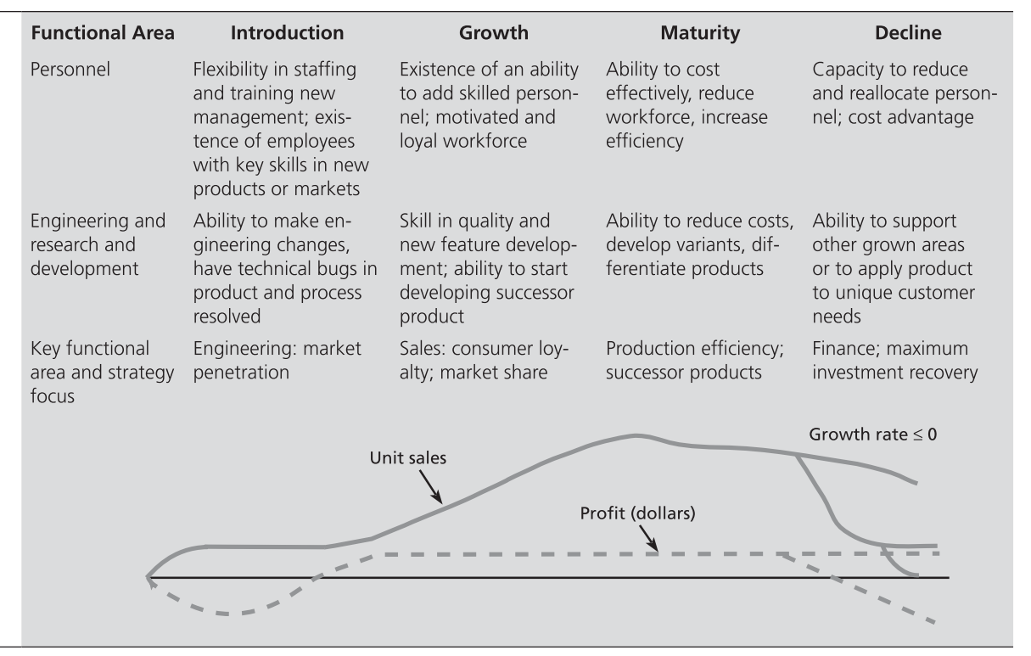

### Competitive advantage and strategic choices in emerging industry

* Emerging industry
  + An industry that has growing sales across all the companies in the industry based on growing demand for the relatively new products, technologies, and/or services made available by the firms participating in this industry
  + Have newly formed or reformed industry that created by technological innovation, new customer needs, or other economic or sociological changes
* Characteristics of business strategy
  + Technologies that are mostly proprietary to the pioneering firms and technological uncertainty about how product standardization will unfold
  + Competitor uncertainty because of inadequate information about competitors, buyers, and the timing of demand
  + High initial costs but steep cost declines as the experience curve takes effect
  + Few entry barriers, which often spurs the formation of many new firms
  + First-time buyers requiring initial inducement to purchase and customers confused by the availability of a number of nonstandard products
  + Inability to obtain raw materials and components until suppliers gear up to meet the industry’s needs
  + Need for high-risk capital because of the industry’s uncertainty prospects
* Features
  + The ability to shape the industry’s structure based on the timing of entry, reputation, success in related industries or technologies, and role in industry associations.
  + The ability to rapidly improve product quality and performance features.
  + Advantageous relationships with key suppliers and promising distribution channels.
  + The ability to establish the firm’s technology as the dominant one before technological uncertainty decreases.
  + The early acquisition of a core group of loyal customers and then the expansion of that customer base through model changes, alternative pricing, and advertising.
  + The ability to forecast future competitors and the strategies they are likely to employ.

### Competitive advantages and strategic choices in growing industries

* Growth industry strategies
  + Business strategies that may be more advantageous for firms participating in rapidly growing industries and markets
  + Emphasize
    - Brand recognition
    - Product differentiation
    - Financial resources to support both heavy marketing expenses
    - Effect of price competition on cash flow
* Accelerating demand means scaling up production or service capacity to meet the growing demand
  + Place a premium on being able to adapt product design and production facilities to meet rapidly increasing demand effectively
  + Increased investment in plant and equipment, in research and development, and especially marketing efforts to target specific customer groups along with developing strong distribution capabilities place a demand on the firm’s capital resources
* Require features
  + The ability to establish strong brand recognition through promotional resources and skills that increase selective demand.
  + The ability and resources to scale up to meet increasing demand, which may involve production facilities, service capabilities, and the training and logistics associated with that capacity.
  + Strong product design skills to be able to adapt products and services to scaled operations and emerging market niches.
  + The ability to differentiate the firm’s product[s] from competitors entering the market.
  + R&D resources and skills to create product variations and advantages.
  + The ability to build repeat buying from established customers and attract new customers.
  + Strong capabilities in sales and marketing.

### Competitive advantages and strategic choices in mature industry environment

* Mature industry strategies
  + Strategies used by firms competing in markets where the growth rate of that market from year to year reached or is closed to zero
* Requires elements
  + Product line pruning, or dropping unprofitable product models, sizes, and options from the firm’s product mix.
  + Emphasis on process innovation that permits low-cost product design, manufacturing methods, and distribution synergy.
  + Emphasis on cost reduction through exerting pressure on suppliers for lower prices, switching to cheaper components, introducing operational efficiencies, and lowering administrative and sales overhead.
  + Careful buyer selection to focus on buyers who are less aggressive, more closely tied to the firm, and able to buy more from the firm.
  + Horizontal acquisition to acquire rival firms whose weaknesses can be used to gain a bargain price and that are correctable by the acquiring firms.
  + International expansion to markets where attractive growth and limited competition still exist and the opportunity for lower-cost manufacturing can influence both domestic and international costs.
* Avoid pitfalls
  + Make a clear choice among the three generic strategies and avoid a middle-ground approach, which could confused both knowledgeable buyers and the firm’s personnel
  + They must avoid sacrificing market share too quickly for short-term profit
  + Avoid waiting too long to respond to price reductions, retaining unneeded excess capacity, engaging in sporadic or irrational efforts to boost sales, and placing their hopes on new products, rather than aggressively selling existing products

### Competitive advantages and strategic choices in decking industries

* Declining industry
  + An industry in which the trend of total sales as an indicator of total demand for an industry’s products or services among all the participants in the industry have started to drop from the last several years with the likelihood being that such a trend will continue indefinitely
  + Caused by
    - Technological substitution
    - Demographic shifts
    - Shifts in needs
* Emphasize
  + - Focus on segments within the industry that offer a chance for higher growth or a higher return.
    - Emphasize product innovation and quality improvement, where this can be done cost effectively, to differentiate the firm from rivals and to spur growth.
    - Emphasize production and distribution efficiency by streamlining production, closing marginal production facilities and costly distribution outlets, and adding effective new facilities and outlets.
    - Gradually harvest the business—generate cash by cutting down on maintenance, reducing models, and shrinking channels and make no new investment.

## Competitive advantage in fragmented industries

* Fragmented industry
  + An industry in which there are numerous competitors such that no single firm or small group of firms controls any significant share of the overall industry sales
* Competitive advantage can be created through
  + Tightly managed decentralization
  + “Formula” facilities
  + Increased value added
  + Specialization
    - Product type
      * The firm builds expertise focusing on a narrow range of products or services
    - Customer type
      * The firm becomes intimately familiar with the serves the needs of a narrow customer segment
    - Type of order
      * The rim handles only certain kinds of orders, such as small orders, custom orders, or quick turnaround orders
    - Geographic area
      * The firm blankets or concentrates on a single area
  + Bare bones/no frills
    - Low posture, low overhead, minimum wage employees, tight cost control, may build a sustainable cost advantage in this kind of industry

## Competitive advantage in global industry

* Global industry
  + Industry in which competition crosses national borders
* Four unique strategy-shaping features
  + Differences in prices and costs from country to country due to currency exchange fluctuations, differences in wage and inflation rates, and other economic factors.
  + Differences in buyer needs across different countries.
  + Differences in competitors and ways of competing from country to country
  + Differences in trade rules and governmental regulations across different countries.
* Two fundamental requirement
  + The approach used to gain global market coverage
  + The generic competitive strategy
  + Basic options
    - License foreign firms to produce and distribute the firm’s products
    - Maintain a domestic production base and export products to foreign countries
    - Establish foreign-based plants and distribution to compete directly in the markets of one or more foreign countries
* For market coverage decision, the four common generic competitive strategies
  + Broad-line global competition—directed at competing worldwide in the full product line of the industry, often with plants in many countries, to achieve differentiation or an overall low-cost position.
  + Global focus strategy—targeting a particular segment of the industry for competition on a worldwide basis.
  + National focus strategy—taking advantage of differences in national markets that give the firm an edge over global competitors on a nation-by-nation basis.
  + Protected niche strategy—seeking out countries in which governmental restraints ex- clude or inhibit global competitors or allow concessions, or both, that are advantageous to localized firms.

# Dominant product/service business: evaluating and choosing to diversify to build value

* 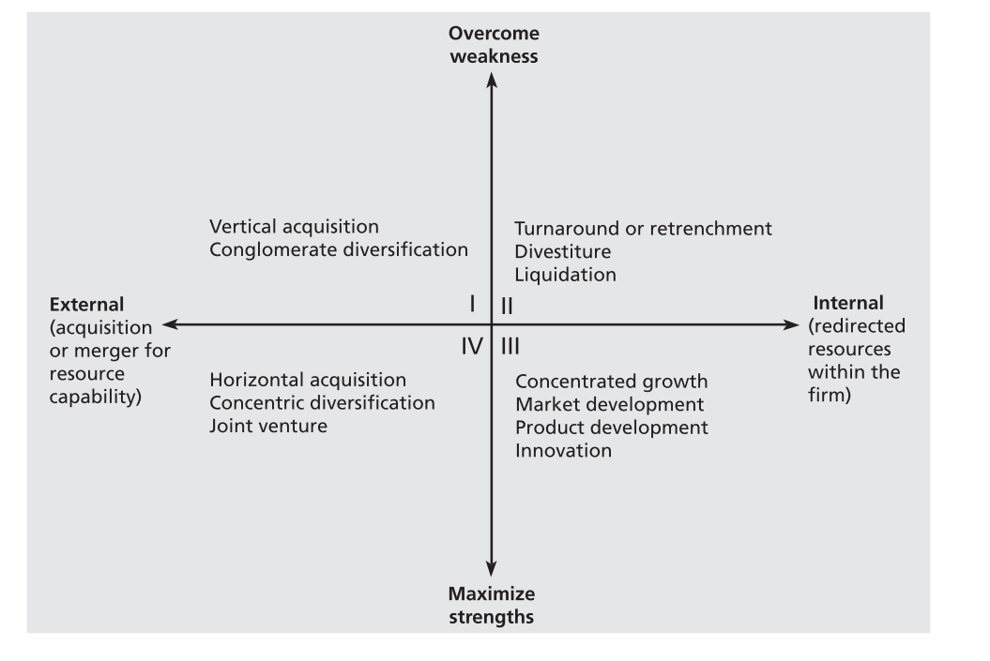

## Grand strategy selection matrix

* Grand strategy selection matrix
  + A four cell guide to strategies based upon whether the business is
    - Operating from a position of strength or weakness
    - Rely on its own resources versus having to acquire resources via merger or acquisition
  + A better guide by the conditions of the planning period and by the company strengths and weaknesses
* Vertical acquisition
  + Acquisition of firms that supply inputs such as raw material, or customers for its outputs, such as warehouses for finished products
* Conglomerate diversification
  + Acquiring or entering businesses unrelated to a firm’s current technologies, markets, or products
* Retrenchment
  + Cutting back on products, markets, operations because the firm’s overall competitive and financial situation cannot support commitments needed to sustain or build its operations.
* Divestiture
  + The sale of a firm or a major component
* Liquidation
  + Closing down the operations of a business and selling its assets and operations to pay its debts and distribute any gains to stockholders
* Concentrated growth
  + Aggressive market penetration where a firm’s strong position and favorable market growth allow it to “control” resources and effort for focus growth
* Market development
  + Selling present products, often with only cosmetic modification, to customers in related marketing areas by adding channels of distribution or by changing the content of advertising or promotion.
* Product development
  + The substantial modification of existing products or the creation of new but related products that can be marketed to current customers through established channels.
* Innovation
  + A strategy that seeks to reap the initially high profits associated with customer acceptance of a new or greatly improved product
* Horizontal acquisition
  + Growth through the acquisition of one or more similar firms operating at the same stage of the production-marketing chain.
* Concentric diversification
  + Acquisition of businesses that are related to the acquiring firm in terms of technology, markets, or products.
* Joint ventures
  + Commercial companies created and operated for the benefit of the co-owners; usually two or more separate companies that form the venture.
* Strategic alliances
  + Partnerships that are distinguished from joint ventures because the companies involved do not take an equity position in one another.
* 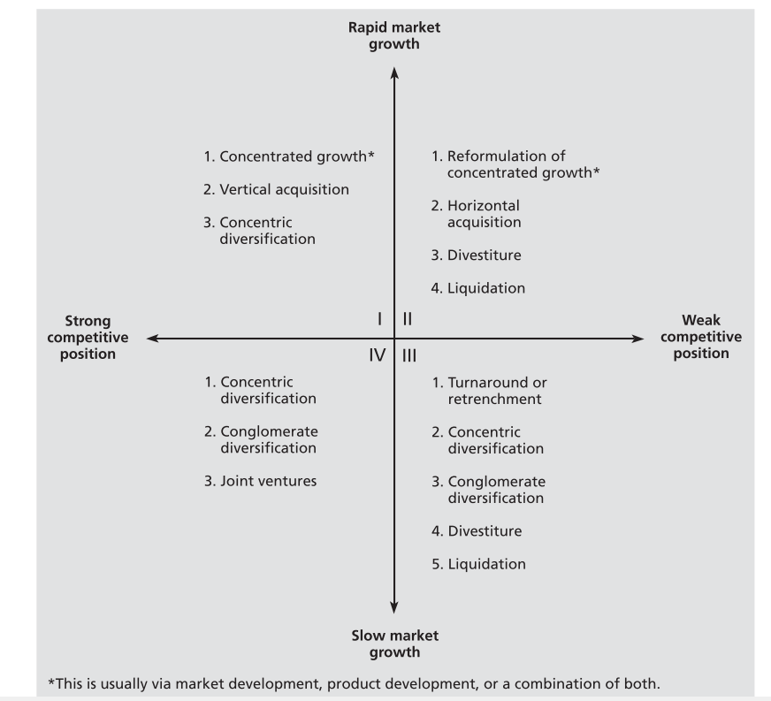

## Model of grand strategy cluster

* Grand strategy clusters
  + Strategies that may be more advantageous for firms to choose under one of four sets of conditions defined by market growth rate and the strength of the firm’s competitive position
* Firms in quadrant I are in an excellent strategic position
  + Continued concentrate on their current business as it is currently defined
* Firms in quadrant II must serious evaluate their present approach to the marketplace
  + It must determine
    - Why that strategy is ineffectual
    - Whether it is capable of competing effectively
* The quadrant III and expect a continuation of slow market growth and a relatively weak competitive position will usually attempt to decrease their resource commitment to that business
* Quadrant IV business have a basis of strength from which to diversify into more promising growth areas
  + Have characteristically high cash flow levels and limited internal growth needs
  + In an excellent position for concentric diversification into ventures that utilize their proven acumen

## Opportunities for building value as a basis for choosing diversification or acquisition

* Page 92

What is the difference between competitive advantages and strategies